**Three T Productions** present

**SUNSTROKE**

Written & Directed by Nikita Mikhalkov

**RUSSIA - RATIO 2.39 - SOUND 5.1 - COLOR**

**SYNOPSIS**

1920. The final days of Imperial Russia: the Communist revolution is underway. The last soldiers loyal to the Tsar are held in a prison camp awaiting Moscow's decision regarding their fate... The Lieutenant recalls his encounter, years before, with a beautiful and enigmatic woman.

During the course of a steam boat journey their paths crossed briefly. The Woman was married, and The Lieutenant himself engaged, but despite every obstacle, the attraction was overpowering. Their 'sunstroke', as they called it, led them into a night of passion, a single night of such sensual intensity that The Lieutenant remembers it to this day, even now clinging to this memory of an opulent Russia and a better life...

**DIRECTOR’S INTENTION NOTE**

I have travelled a long way towards this film. For almost 40 years I have time and time again returned to the idea of filming “The Sunstroke”. It is not an average love story. “The Sunstroke” is a providence, magic, something unperceivable and elusive, something that only two people comprehend. I’ve copied the Bunin’s story by hand eleven times, trying to merge into its energy, to catch the intangible aura of its language. But in order to reach the mystery of this short story, to comprehend its atmosphere, you have to try to understand Bunin himself. And at certain point I understood that I need to show the diverse Bunin, a person of contrast, recognizable and completely unknown. That’s how I came to an idea to combine “The Sunstroke” and “Cursed Days”, where the destiny of main heroes is like a common thread running through the life and destruction of great Russia, of the Russian world.

Eventually we have concentrated on the most important, the central question of the picture: how did all this happen? How did the sunstroke happen? How did the cursed days happen? How was the sunstroke replaced by the cursed days? Where is this edge that has divided the epochs?

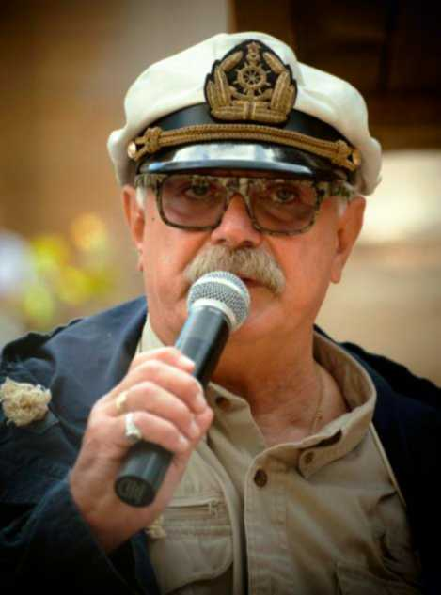

**Nikita MIKHALKOV – Director & Writer**

He was born on October 21, 1945 in Moscow.

Father – poet Sergey Vladimirovich Mikhalkov (1913-2009), lyricist of the national anthem of the Soviet Union and Russia; mother – writer Natalia Petrovna Konchalovskaya (1903-1988).

In 1959, he first played a cameo role in the film by Vasily Ordynskiy *Clouds Over Borsk*, in 1961, he played in the film by Genrikh Oganesyan *Adventures of Krosh*, and while still a student of the Shchukin School, in 1963 he starred in Georgi Daneliya’s film *I Step Through Moscow*. In 1963-1966, he studied acting at the Shchukin Higher Drama School.

In 1971, he graduated from the State Institute of Cinematography (VRIK) where he studied directing (class of M.I. Romm).

His first short feature film *I’m Coming Home* he directed in 1968, and another for his graduation, *A Quiet Day at the End of the War*, in 1970.

The first notable feature film directed by Nikita Mikhalkov was *At Home Among Strangers* (1974), in which he played the lead role in addition to directing and co-writing. This adventure film was in fact the first of the so-called “westerns” in the Soviet cinema. Mikhalkov became internationally recognized after his film *An Unfinished Piece for a Player Piano* (1977), which won the first prize at the San Sebastian Film Festival. His films *Slave of Love* (1976), *Five Evenings* (1979), *A Few Days in the Life of I.I.* *Oblomov* (1980), *Kindred* (1982), *Without Witnesses* (1983) are also loved by both audience and critics. Marcello Mastroianni, who played a starring role in Mikhalkov’s film *Dark Eyes* (1987), won the Best Actor Prize at the Cannes Film Festival and an Academy Award (Oscar) Best Actor nomination.

In the late 1980’s, Mikhalkov established a creative and production association TRITE (TRITE is an abbreviation of three Russian words: Tvorchestvo, Tovarishchestvo, Trud (Creativity, Partnership, Work)). In 1993, Nikita Mikhalkov’s film *Urga: The Territory of Love* (1992) received a nomination for an Academy Award Best Foreign Film. In 1994, Mikhalkov at the same time produced, directed, wrote and starred in the film *Burnt by the Sun*, which won the long-awaited Oscar (Academy Award Best Foreign Film) and the Grand Prix at the Cannes Film Festival. Once again he produced, directed, wrote and starred in his new international project *The Barber of Siberia* in 1998, which was released in Russia in 1999.

As an actor he appeared in such films as *Siberiade* by A.S. Konchalovsky, *A Station for Two* and *A Cruel Romance* by Eldar Ryazanov, *Humiliation and Offense* by Andrey Echpai, *Adventures of Sherlock Holmes and Doctor Watson.* *The Hound of the Baskervilles* by Igor Maslennikov, and in many others. In recent years, he played brilliant roles in the films *The State Counsellor* by Philip Yankovskiy, *Zhmurki* by Alexey Balabanov and *Persona Non Grata* by Krzysztof Zanussi.

In 2003, Nikita Mikhalkov was actively engaged in documentary journalism. Together with the TV channel *Russia* he released a series of programs about the White Guard, namely *Nikita Mikhalkov.* *The Russian Choice.* In the same year, there were released two documentary films *Father* and *Mother* dedicated to the 90th anniversary of Sergey Mikhalkov and the 100th anniversary of Natalia Konchalovskaya.

People’s Artist of the Russian Federation (1984).

President of the Russian Fund of Culture (1993).

Chairman of the Union of Cinematographers of the Russian Federation.

Member of the Presidential Council for Culture and Arts.

President of the Moscow International Film Festival.

Head of TRITE Studio where over the last 20 years he has made all of his films.

**Producer:**

* Legend No. 17 (2013)
* The Spy (2012)
* The House on the Side of the Road (2012)
* Burnt by the Sun-2: Citadel (2010)
* Burnt by the Sun-2: Exodus (2010)
* 12 (2007)
* 1612 (2006)
* Persona Non Grata (2005)
* General Kozhugetych (2005)
* The State Counsellor (2005)
* Father (2003)
* Mother (2003)
* Tender Age (2000)
* The Barber of Siberia (1999)
* Burnt by the Sun (1994)
* Anna from 6 to 18 (documentary film) (1993)

**Honors and awards:**

* Prize for Best Director, 1984.
* Top Prize at the Venice Film Festival, 1991.
* Kinotavr Award Top Prize, 1992.
* Nika Award for Best Director, 1992.
* Feliks Award for Best Film, 1993.
* Academy Award for Best Foreign Film, 1994.
* Khanzhonkov Medal “Cinema Event of the Year” for hosting the XXI Moscow International Film Festival (1999).
* State Prize of the Russian Federation in literature and arts (2000) for *The Barber of Siberia*.
* XVI Kinotavr Prize “For Personal Contribution to Cinema Development”. Golden Eagle Award for Best Actor in 2006 (*The State Counsellor*).
* Full Cavalier of the Legion of Honor (1992), Commander of the Legion of honor (gold star with emeralds and ribbon around the neck) - for contribution to the world culture (France, 1994), Class III Order of Merit for the Fatherland (1995), Class I Order of Sergius of Radonezh of the Russian Orthodox Church (1997), etc.
* Akira Kurasava Prize in the amount of 50 thousand US dollars at the 21st International Film Festival in Tokyo.
* Special Prize *Golden Lion* at the International Film Festival in Venice (2007)
* Prize of the National Academy of Cinematographic Arts and Sciences of Russia *Golden Eagle* for Best Film of the Year (2008)
* Academy Award (Oscar) nomination for Best Foreign
* Film (2008)
* Class IV Order of Merit for the Fatherland (Decree No. 1278 of the President of Russia dated 21/10/2010)

**Martins KALITA – the Lieutenant**

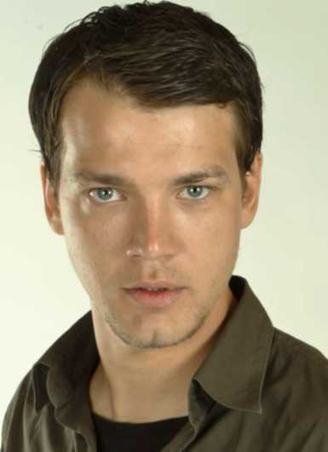He was born on January 25, 1986 in the town of Grobina, near Liepaja (Latvia). Besides Latvian origins, in Martins family there are also German and Russian origins.

In 2009, he graduated from Klaipeda University, actors’ faculty.

The entire class where Martins Kalita studied had an opportunity to get very good skills in acting, singing and dancing. As a result, Martins plays lead roles in Liepaja Theatre in modern large-scale musicals and performances where, in addition to acting, he can demonstrate his dancing and musical skills.

**Filmography:**

* Sunstroke (2014) – film debut

**Stage roles:**

* *Indulis and Aria* by Rainis - as Indulis (2014)
* *Boeing, Boeing* by M. Kamoletti - as Bernard (2014)
* *Spriditis* based on Anna Brigadere’s play - as Wind, Good Fellow (2013)
* *Piaf* by Pam James - as Albert, Raymond, American officer, Yves (2013)
* *The Marriage of Munchausen* by M. Ziverts - as Baron von Munchausen (2013)
* *Lucrezia Borgia* by V. Hugo - as Gennaro (2013)
* *Punishment and Crime* (based on L. Andreev’s play *Ekaterina Ivanovna*) - as Alexey Dmitrievich Stibelov (2012)
* *Advents Silmacos* - as Alexis (2012)
* *Blow, Wind!* based on the play by Rainis and Latvian folk songs - in the role of Paren (2011)
* *Chic Wedding* - as Bill (2011)
* *West Side Story* by L. Bernstein, J. Robbins, A. Laurent, S. Sondheim - as Bernardo or Chino (2010)
* *In the Fire* - as Edgars, groom (2010)
* *The Glass Menagerie* - as Toms (2010)
* *Love, Jazz, and the Devil* - as Mad orator, Boy, Mad (2010)
* *The Battle of...* as Teacher (2009)
* *Two Jokes by Chekhov* (a play in one act *The Bear*) - as Grigory Stepanovich Smirnov (2009)
* *Two Jokes by Chekhov* (a play in one act *The Jubilee*) - as Representative of the Bank Directors’ Delegation (2009)

Martins Kalita also draws pictures very well. He dreams to become a filmmaker in the future.

***Exclusive agent Gordana Milevic says about Martins Kalita:***

*“When I saw Martins Kalita three years ago on the stage of Liepaja Theatre, I was impressed by his talent and it struck me immediately that this was the new star of international level. When I became aware from Mosfilm about the casting for Nikita Mikhalkov’s film Sunstroke, I told the casting director Larisa Sergeeva about Martins and showed her some of his photos. I also asked Martins to make a video-showreel in order to demonstrate his talented work. Martins’ parents had horses, and I asked for a video with him riding a horse. Martins had difficult rehearsing in the theater and had no time to spare. But a desire to act in a film of the director, who had always been respected and loved by all his family, was very large. Martins made a vivid video which at once showed all the emotions of the actor, his willingness to play in a great movie, and his potential. A few days later, Martins was invited to an open call to Nikita Mikhalkov and approved for the lead role. For a young actor it is great happiness to get to the maitre of the Russian cinema at the outset of his career and show his talent”.*

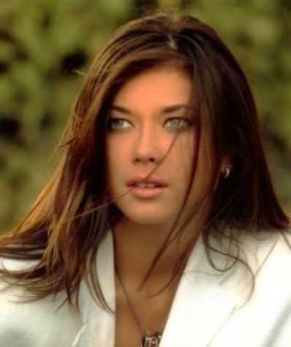**Victoria SOLOVIEVA – the Stranger**

She was born on February 23, 1989 in the town of Torez, the Donetsk Oblast (Ukraine).

She wanted to obtain a higher education in Kiev, entered Dragomanov National Pedagogical University, practical psychology faculty, and completed 2 years.

In 2009, she entered Shchepkin Higher Drama School, class of V.M. Beilis/V.N. Ivanov. In her graduating performance she played the role of Catherine I, the wife of Peter the Great.

In 2013, she became winner of Prize II of XVIII Yermolova Competition of Students’ Works in Art of Declamation.

**Diploma thesis:**

* *Zoyka’s Flat* by М. Bulgakov, directed by drama teacher E. Dmitrieva - the role of Maniushka
* *Argus* by M. Cervantes, directed by drama teacher A. Dubrovsky - the role of Hostess

In September 2013, she was employed by Lenkom Theater, and successfully entered the action in the role of Catherine I in the performance *Balakirev The Buffoon*.

**Filmography:**

Sunstroke (2014) – film debut

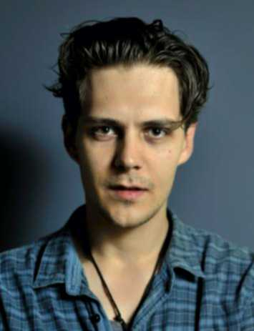

**Milos BIKOVIC**

He was born on January 13, 1988 in Belgrade (Yugoslavia, Serbia).

Milos Bikovic has become one of the most popular young actors in Serbia and the former Yugoslavia through historical film and TV series *Montevideo, Bog te video!* where he played the lead role.

Milos Bikovic always dreamed of coming to Russia and playing in Nikita Mikhalkov’s films. He did not know about the casting for the film *Sunstroke*. Talking to his brother, an Orthodox priest, Milos told him that he wanted to play in Nikita Mikhalkov’s films. The brother advised - “write him a letter...”. Milos sent a letter to Mikhalkov and then he became actor of the film project *Sunstroke*. He spoke Russian not very well but a great effort and a very good teacher in Moscow gave Milos an opportunity to quickly achieve great success in the knowledge of Russian.

Work in the film *Sunstroke* which gave him an opportunity to star further in Russia. Filming of the motion picture *Soulless-2* has just finished, in this film Milos Bikovic played the second lead role along with Danila Kozlovskiy.

In the future he wants to develop himself as a director, make films and foster cultural relations of Russia and Serbia.

*Exclusive agent Gordana Milevic says about Milos Bikovic:*

*“Tremendous energy of Milos, desire to develop himself, achieve very ambitious goals, hard work and talent, willingness to overcome a lot for a good role, love for Russia - all of this opens up new horizons for him, which is very important for a young actor”.*

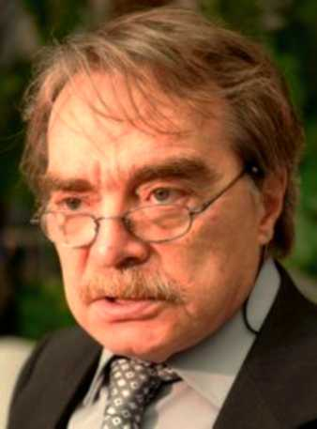**Alexander ADABASHYAN**

**Co-author of the screenplay and actor of Sunstroke film**

He was born on August 10, 1945 in Moscow.

He graduated from Moscow Higher Art School. He has been working in film industry since 1974.

Author or co-author of 23 film screenplays. Together with Nikita Mikhalkov, Alexander A. Adabashyan wrote screenplays of the films *An Unfinished Piece for a Player Piano* (1977), *Five Evenings* (1979), *A Few Days from the Life of I.I. Oblomov* (1980). In addition, on the set of these films he was the art director together with A. Samulekin.

As the director he produced the film *Mado, Poste Restante* in France in 1992. Another director’s work of Alexander Adabashyan in cinema is the film adaptation of Boris Akunin’s novel-detective *Azazel* (2002).

Aleksandr Adabashyan played roles in thirty-nine motion pictures. His roles in such films as *Five Evenings* and *The Hound of the Baskervilles* are among the most successful and memorable. Just say: “Porridge, Sir!”- and the face of an honest average viewer will expand in a happy smile of recognition, because many years ago the role of Butler Barrymore in the TV series about Sherlock Holmes suddenly became an icon of Alexander Adabashyan’s actor image. Besides, it stands to mention his roles in the films *The City Accepted*, *Bless Me, My Talisman*, *Presence*.

Aleksandr Adabashyan staged two operas - *Boris Godunov* at the Mariinsky Theatre (1997) and *Khovanshchina* at La Scala (1997). Aleksandr Adabashyan works as the Decorator (restaurant *Oblomov*), an exhibition of his paintings took place in the Central House of Artists.

Honored Artist of the RSFSR (1983).

**Prizes and awards:**

* Winner of the State Prize of the Kazakh SSR (1978).
* Fellini Prize for Best European Screenplay (1993).
* Flaiano Silver Pegasus Award for Best Foreign Screenplay (1991, Italy).

**Vladimir MOISEENKO (1963-2011)**

**Co-author of the screenplay of Sunstroke film**

He was born on March 7, 1963 in Magnitogorsk. In 1996 he graduated from the screen-writing faculty of VGIK. Member of the European Guild of Screen Artists and the Film Guild of Hollywood.

He died on March 22, 2011.

**Filmography:**

* Burnt by the Sun-2: Citadel (2011)
* Return to A (Kazakhstan, Russia) (2011)
* Burnt by the Sun-2: Exodus (2010)
* Five Steps on Clouds (2008)
* Antidur (2007)
* 12 (2007)
* Inhale Exhale (2006)
* Formula (2004)
* Against the Current (2004)
* Cobra. Antiterror (2003)
* The Main Rule No. 2 (2003)
* Return (2003)
* Cobra (Films 1-3) (2001)
* Starye Klyachi (2000)
* Maroseyka 12 (Films 1-3) (2000)
* Strawberry Cafe (Series 3, 29, 31, 43, 55, 118, 124, 125, 133, 136, 156, 161) (1996)

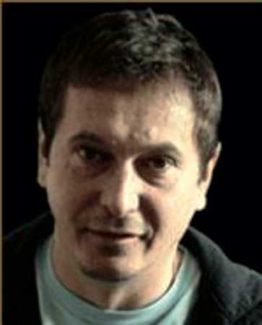**Vladislav OPELIYANTS**

**Director of Photography of Sunstroke film**

He was born on January 7, 1968.

He graduated from VGIK, cinematography faculty (class of V.I. Yusov) in 1992, without graduation.

He worked as cameraman-reporter in Holland.

He is a cinematographer of the famous commercials of the large international and domestic brands. He works in the field of music video. In total, he did more than 100 music videos and commercials.

He debuted in film industry in 1997 with the film *Midlife Crisis* (directed by Garik Sukachev).

**Filmography:**

* The Battle for Immunity (2014) - in production
* Sunstroke (2014)
* A Country in Shop (TV series, 2012)
* Poddubny (2012)
* Burnt by the Sun-2 (TV series, 2011)
* Burnt by the Sun-2: Citadel (2011)
* Burnt by the Sun-2: Exodus (2010)
* Kitty (2009)... ‘Mad Ballerina’
* 12 (mini-series, 2007)
* 12 (2007)
* The State Counsellor (2005)
* Goddess: How I Fell in Love (2004)
* Triumph (2000)
* Midlife Crisis (1997)

**Eduard ARTEMIEV**

**Composer of music for Sunstroke film**

He was born on November 30, 1937 in Novosibirsk.

In 1960, he graduated from Tchaikovsky Moscow State Conservatory, music composition specialty (teachers Yu. Shaporin, N. Sidelnikov). In 1964-1985 he worked as a senior lecturer of orchestration class in the Institute of Culture. Member of the Union of Composers and the Union of Cinematographers of Russia, President of the Russian Association of Electronic and Acoustic Music set up by him in 1990, as well as member of the Executive Committee of the International Confederation of Electronic and Acoustic Music (ICEM) with UNESCO.

He lectures for students-composers of the Moscow Conservatory and conducts master classes.

Honored Artist of the Russian Federation (1985). People’s Artist of the Russian Federation (1999). He wrote film scores of more than 160 films.

**Selected filmography:**

* Legend No. 17 (2012)
* Burnt by the Sun-2: Exodus (2011)
* Burnt by the Sun-2: Citadel (2011)
* 12 (2007)
* Stalker (1979)
* Five Evenings (1978)
* An Unfinished Piece for a Player Piano (1976)
* The Mirror (1974)
* At Home Among Strangers (1974)

**Operas:**

* Crime and Punishment, an opera in two acts based on the novel by F.M. Dostoevsky, libretto by M. Rozovsky and A. Konchalovsky, lyrics by Yu. Ryashentsev (2007)
* Heat of the Earth, an opera in two acts, libretto by E. Kompanets (1988)

**Symphonies, suites, instrumental music:**

* Altay Tale. Flight Over Time, symphonic suite (2012)
* Lubki, a suite for female chorus and orchestra (2010)
* The Pilgrims, a symphony for soprano, tenor and rock band (1982) (not completed)
* Seven Gates into the World of Satori, a quasi-symphony of seven parts for a band of electronic instruments, guitars, drums, violin and soundtrack (1974)
* The Ocean, a symphonic poem (1972)
* For Dead Souls, a score for a ballet-pantomime for an orchestra
* (1965)
* The Cups, a suite for an orchestra and chorus (1962)
* Khorovod, a suite for an orchestra and chorus (1960)
* The Poem, for two violins, viola and cello (1956)

**Works for solo instruments with an orchestra:**

* Concerto for Piano and Orchestra (1994)
* Concerto for Viola and Orchestra (Part I) (1960)

Author of numerous oratorios, cantatas, choral and vocal and instrumental compositions, piano music, electronic music. Author of music for more than thirty theatrical performances.

**Awards and prizes:**

* Class IV Order of Merit for the Fatherland (August 16, 2013)
* Winner of the State Prize of the RSFSR named after Vasilyev brothers for the film *Courier*
* Winner of three State Prizes of Russia in the field of literature and art for the films *Urga* (1993), *Burnt by the Sun* (1995) and *The Barber of Siberia* (1999)
* Winner of three Nika Awards for the best music for the films *Limita* (1995),
* *A Driver for Vera* (2004), *12* (2008)
* Winner of four Golden Eagle Awards for the best music for the films *Doctor Zhivago* (2007), *12* (2008), *The House* (2012), *Legenda No. 17* (2014)
* M. Tariverdiev Award (1999) for the music for the film *Mother*
* Winner of the award “The Art of Uniting People and Information” in the category “Art” (2000)
* Winner of St. George award of XXIII Moscow International Film Festival “For Outstanding Contribution to the World Cinema” (2001)
* Small Gold Medal of VDNH for musical composition *Mosaic* (1968).
* Honorary citizen of Baltimore (USA, 1988)

**CAST**

The Lieutenant Martins Kalita

The Stranger Victoria Solovieva

Second Lieutenant Milos Bikovic

Tatiana Anastasia Imamova

The magician Avangard Leontiev

Egorov Sergey Karpov

The Photographer Alexander Adabashiyan

The Captain Kirill Boltaev

Junker-sword belts Alexander Michkov

George S. Alexey Dyakin

Rotest Vitaliy Kischenko

The country woman Miriam Sekhon

Bela Kun Sergey Bachurskiy

The naval officer Alexander Ustyugov

The Colonel Vladimir Yumatov

**CREW**

**Screenplay** Nikita Mikhalkov

Vladimir Moiseenko

Alexander Adabashiyan

**Direction of photography** Vladislav Opeliyants

**Editor** Svetolik Mica Zaic

**Music** Eduard Artemiev

**Set Designer** Valentin Gidulyanov

**Sound Editor** Vincent Arnardi C.A.S.

Pavel Doreuli

Igor Pokorniy

**Costume Designer** Sergey Struchev

**Special Effects** Peter Gorshenin’s Studio ”F.X. Design Group”